Curve

Definition
# Source: AI Source: Provided by: [Data Path: Persons Table -> ID Column: 1, Name_En Column: Motasem Essam] -> From: [ChatGPT] on [7/25/2026]
A curve in plane geometry is a continuous set of points in a two-dimensional plane that forms a bending or non-straight path. A curve may be open or closed, regular or irregular, and may be described mathematically or represented visually.
$$\boxed{\text{Curve}=\text{Continuous Bending Path in a Plane}}$$
Unlike a straight line or line segment, a curve changes direction continuously or through a sequence of changing directions.
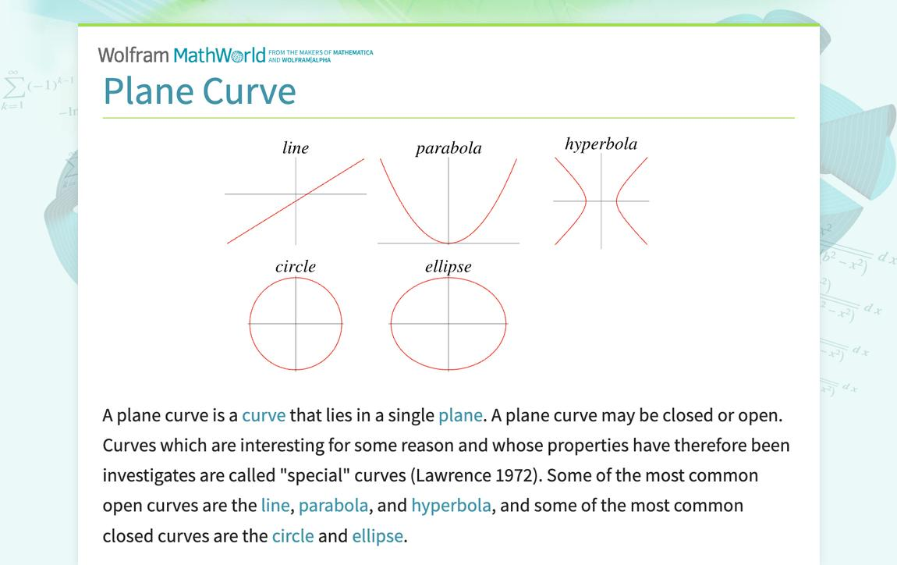
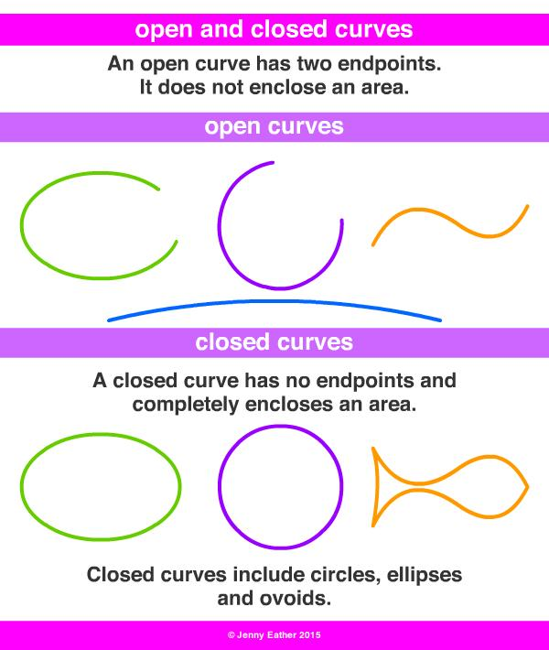
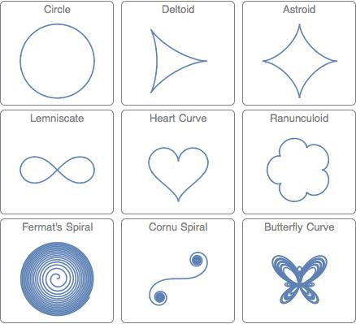
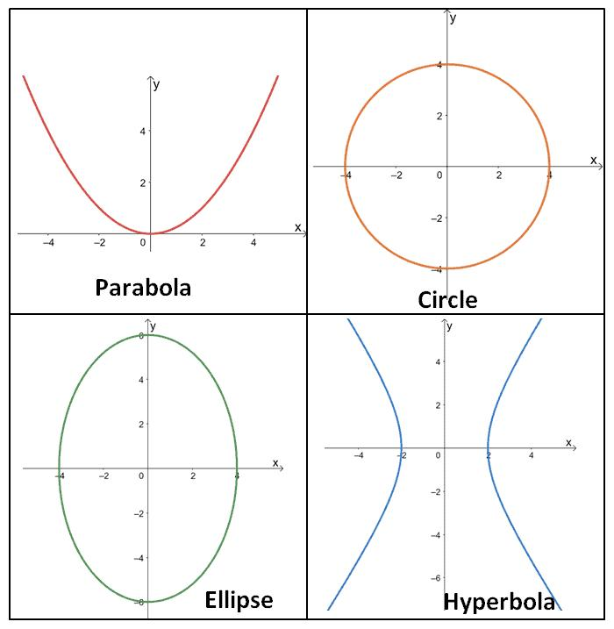
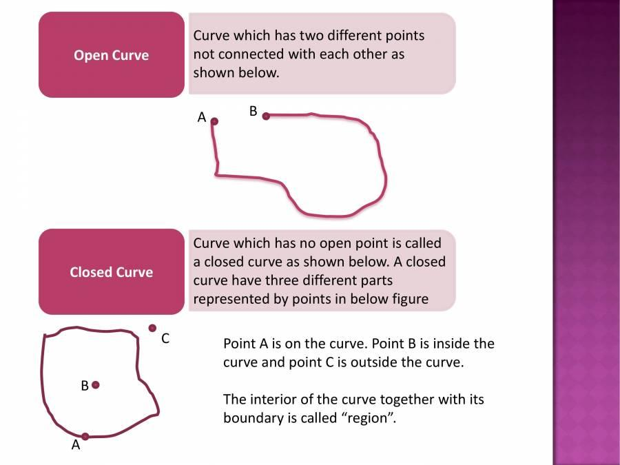
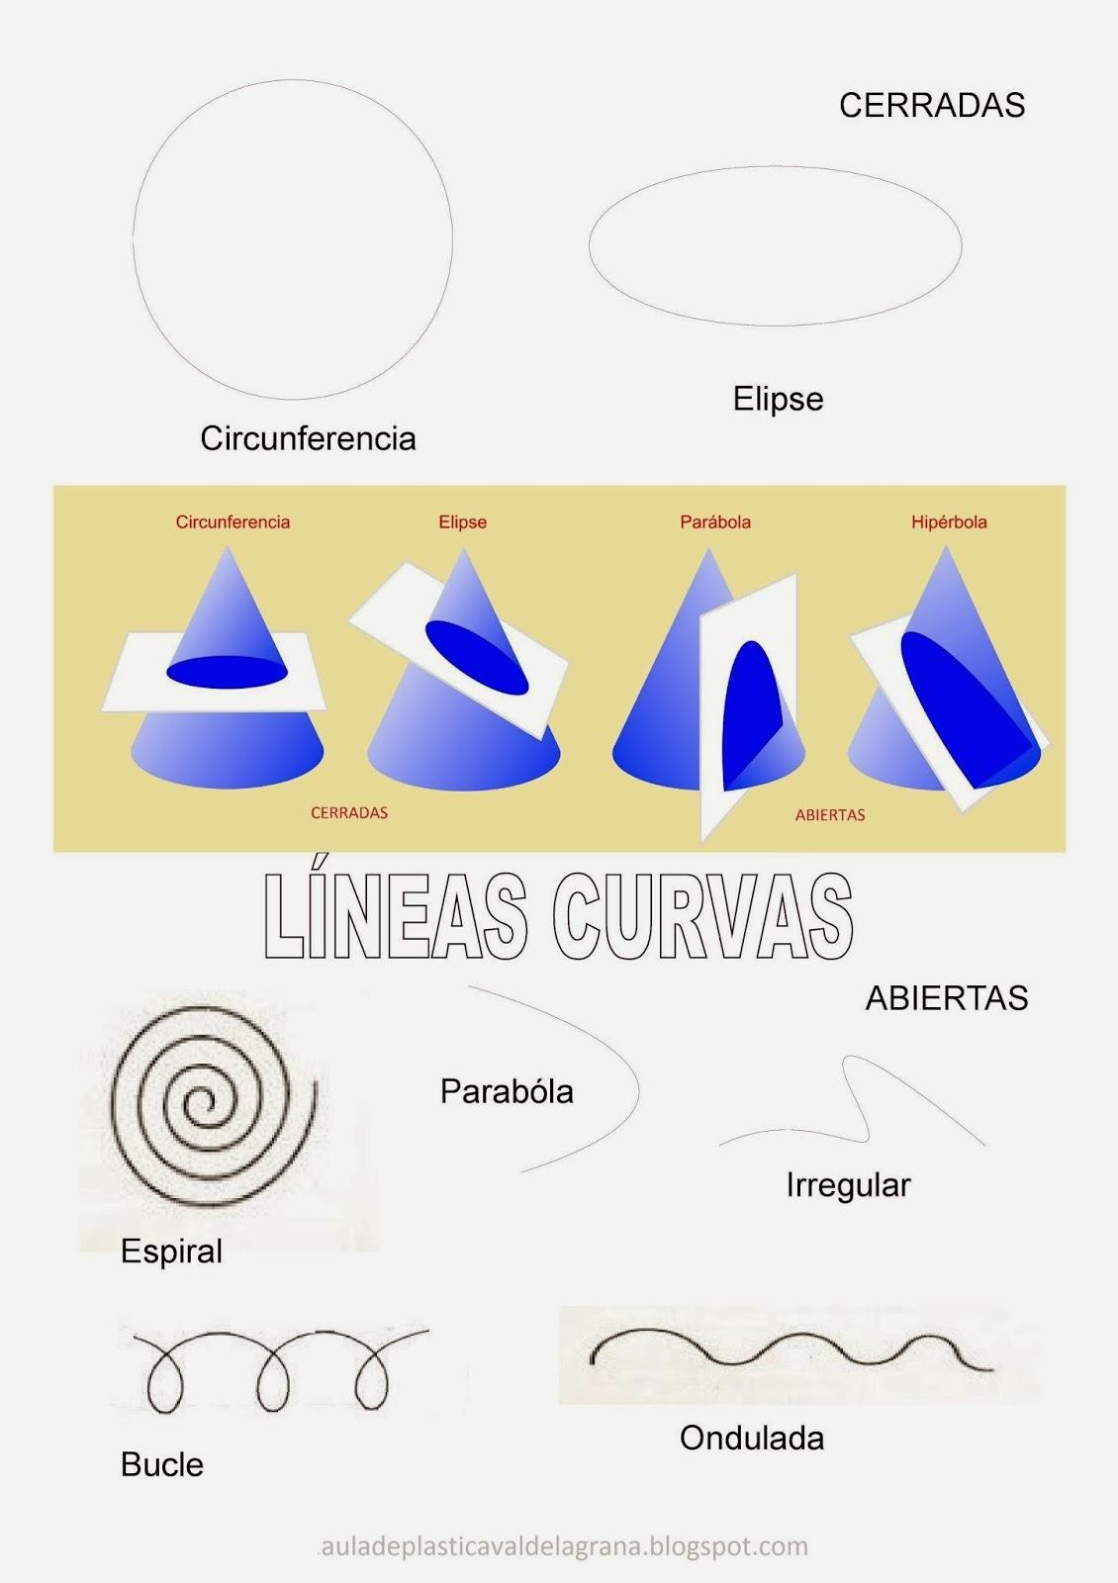

Main Characteristics of Curves
# Source: AI Source: Provided by: [Data Path: Persons Table -> ID Column: 1, Name_En Column: Motasem Essam] -> From: [ChatGPT] on [7/25/2026]
A plane curve can be classified according to several properties:
- Open or closed
- Straight or curved
- Regular or irregular
- Simple or self-intersecting
- Symmetric or asymmetric
- Circular or non-circular
- Smooth or non-smooth
- Convex or concave
- Algebraic or transcendental
- Geometric or freeform

Types of Curves

1. Open Curves
# Source: AI Source: Provided by: [Data Path: Persons Table -> ID Column: 1, Name_En Column: Motasem Essam] -> From: [ChatGPT] on [7/25/2026]
An open curve has two distinct endpoints and does not return to its starting point.
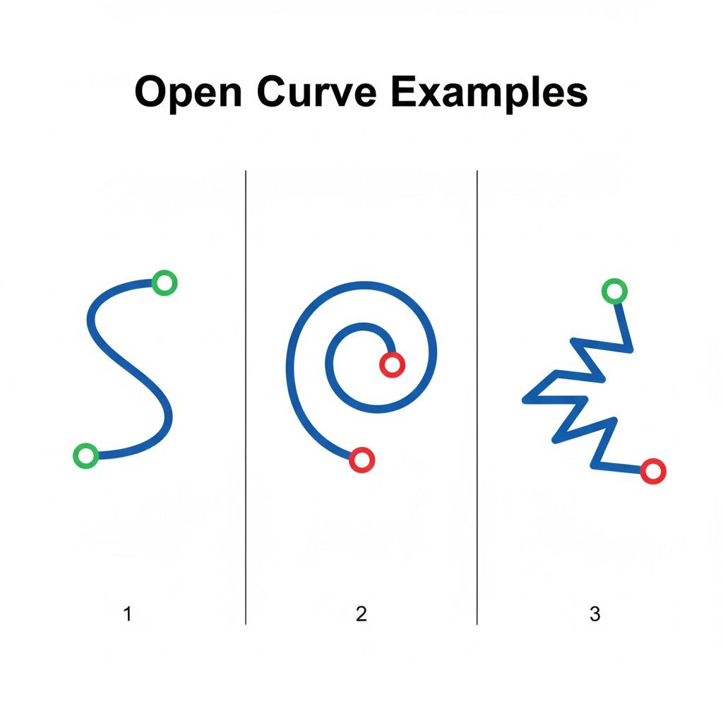
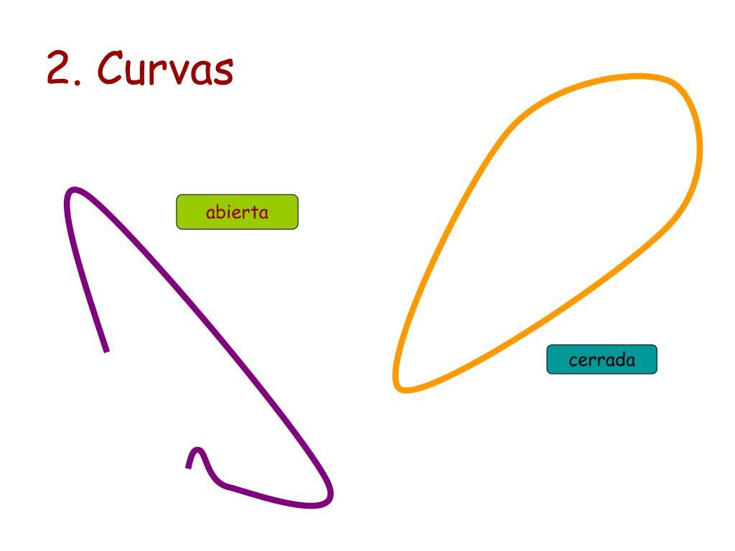
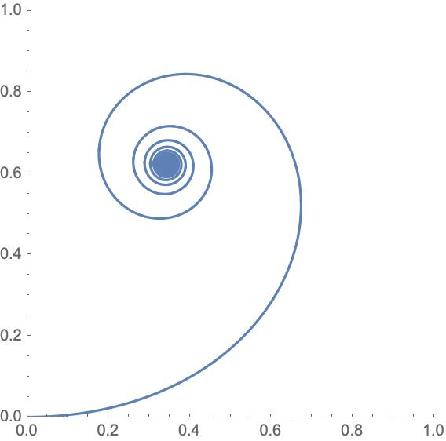
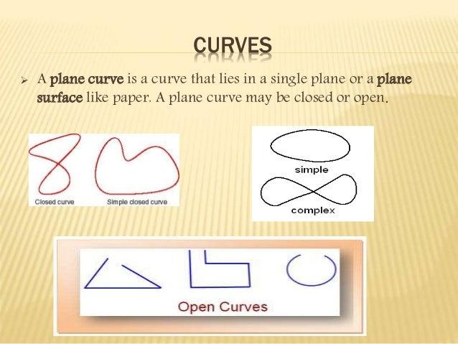
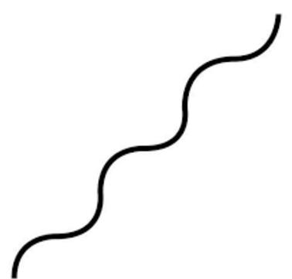
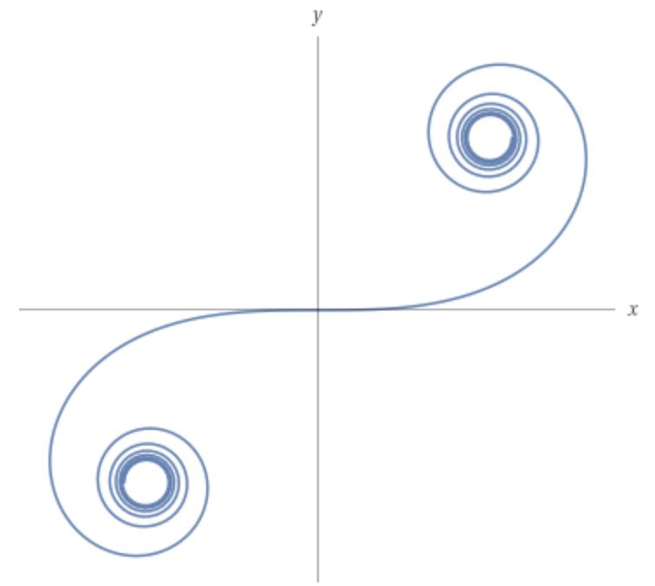
Examples:
- Parabolic curves
- Open elliptical curves
- Hyperbolic curves
- Wavy curves
- Spiral-like curves
- Organic curves
- Freeform curves

2. Closed Curves
# Source: AI Source: Provided by: [Data Path: Persons Table -> ID Column: 1, Name_En Column: Motasem Essam] -> From: [ChatGPT] on [7/25/2026]
A closed curve returns to its starting point and has no endpoints.
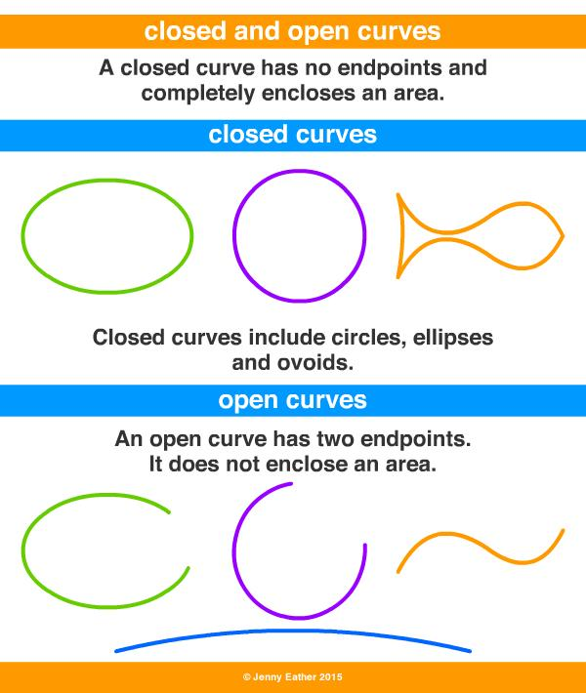
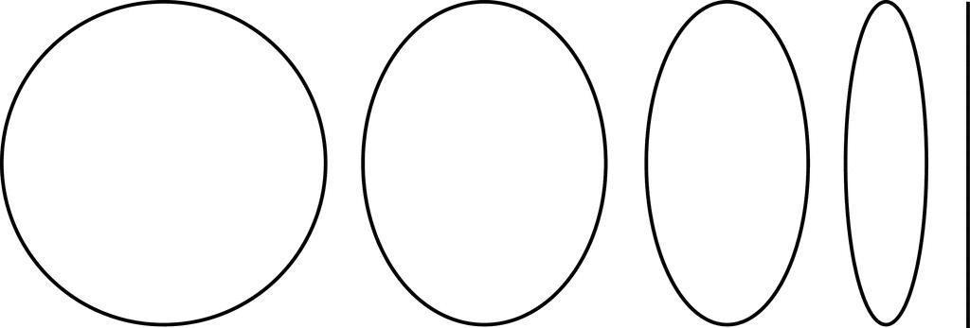
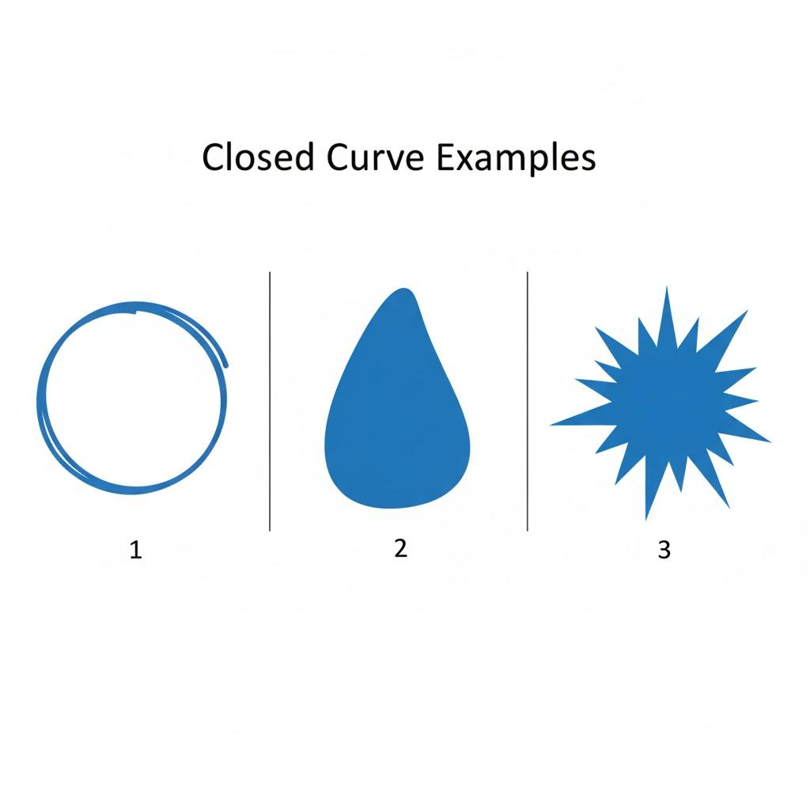
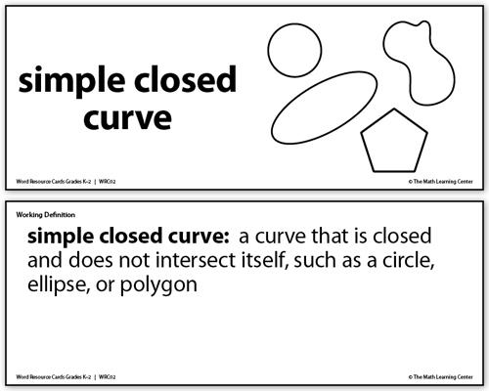
Examples:
- Circles
- Ellipses
- Ovals
- Organic closed curves
- Freeform closed curves
- Wavy closed curves

3. Simple Curves
# Source: AI Source: Provided by: [Data Path: Persons Table -> ID Column: 1, Name_En Column: Motasem Essam] -> From: [ChatGPT] on [7/25/2026]
A simple curve does not cross itself.
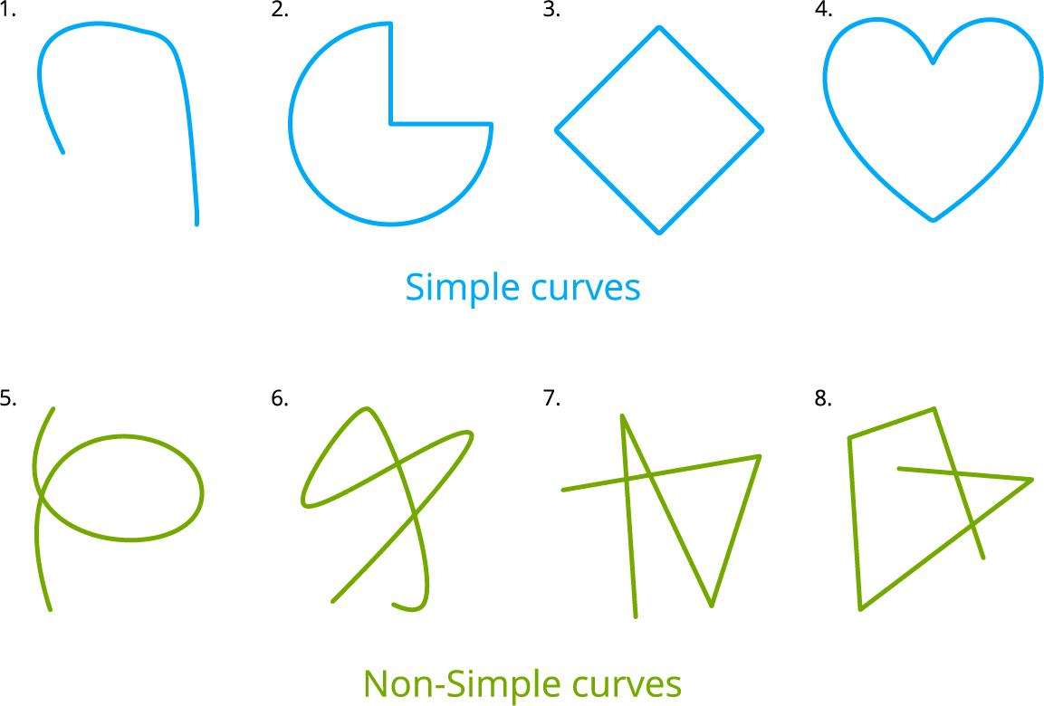
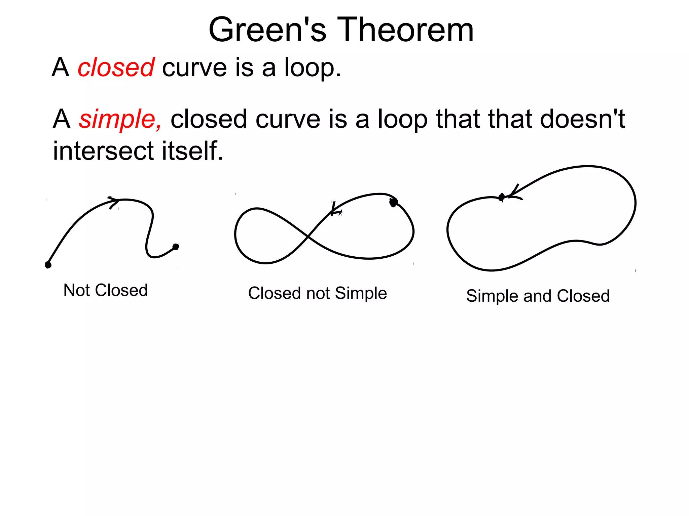
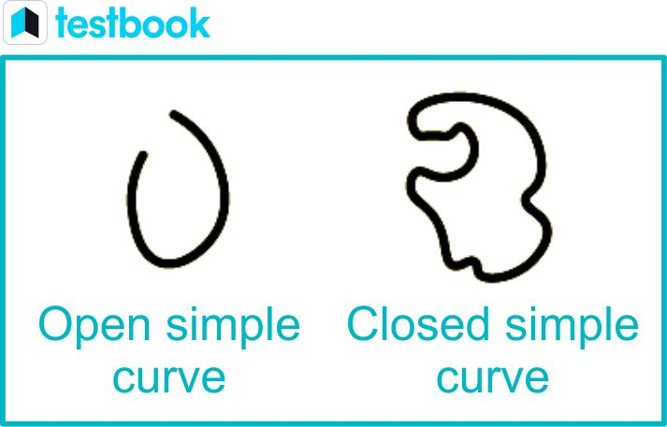
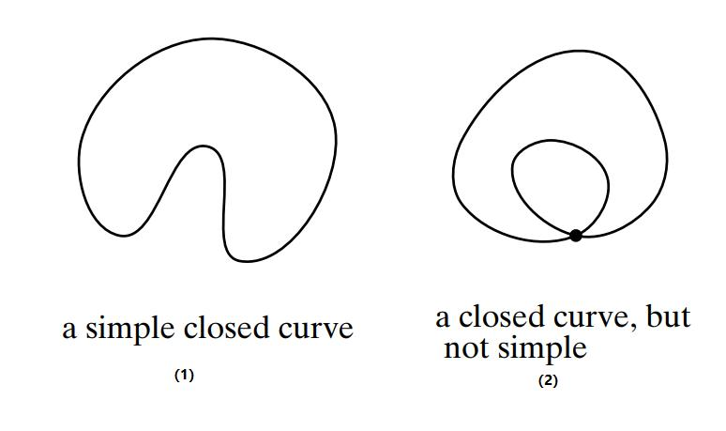
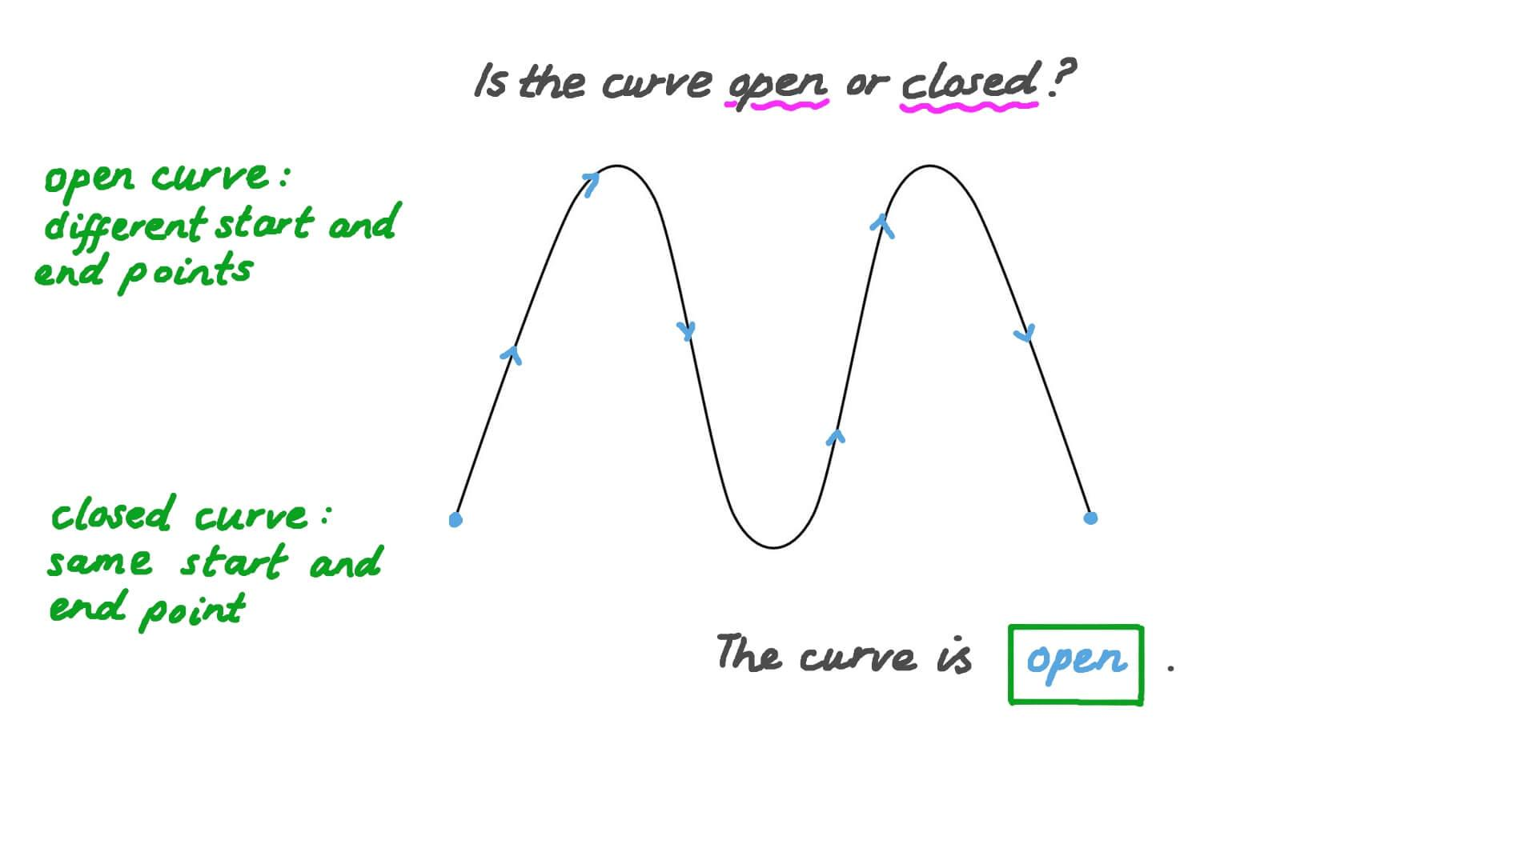

4. Self-Intersecting Curves
# Source: AI Source: Provided by: [Data Path: Persons Table -> ID Column: 1, Name_En Column: Motasem Essam] -> From: [ChatGPT] on [7/25/2026]
A self-intersecting curve crosses itself at one or more points.
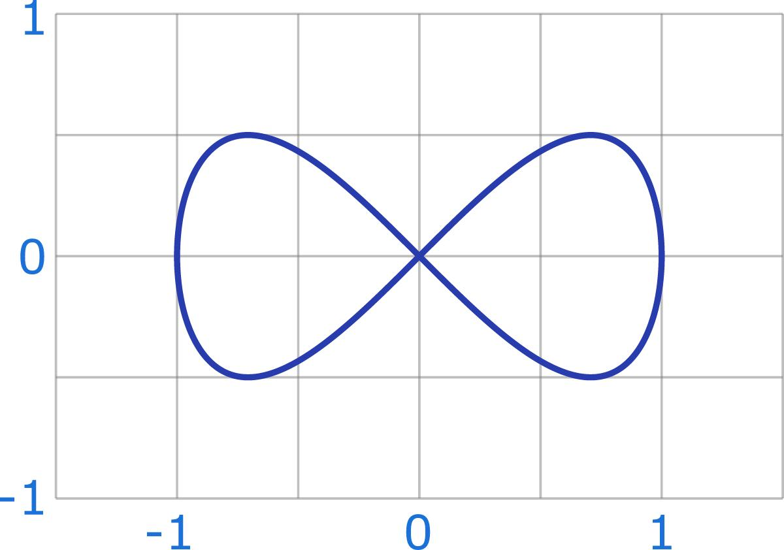
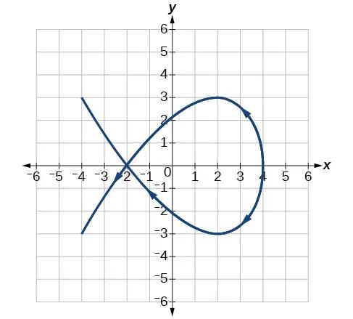
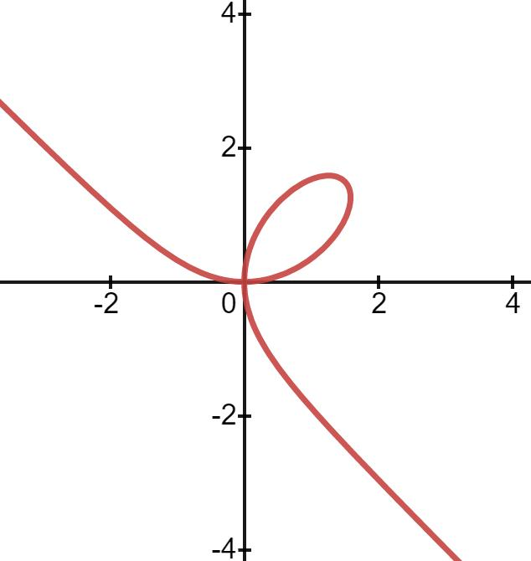
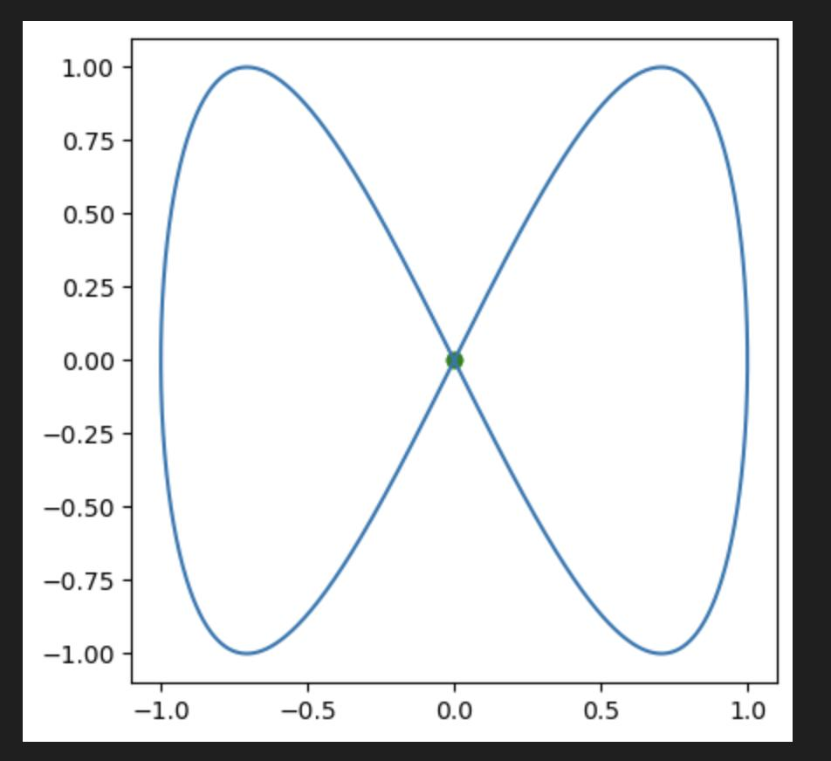
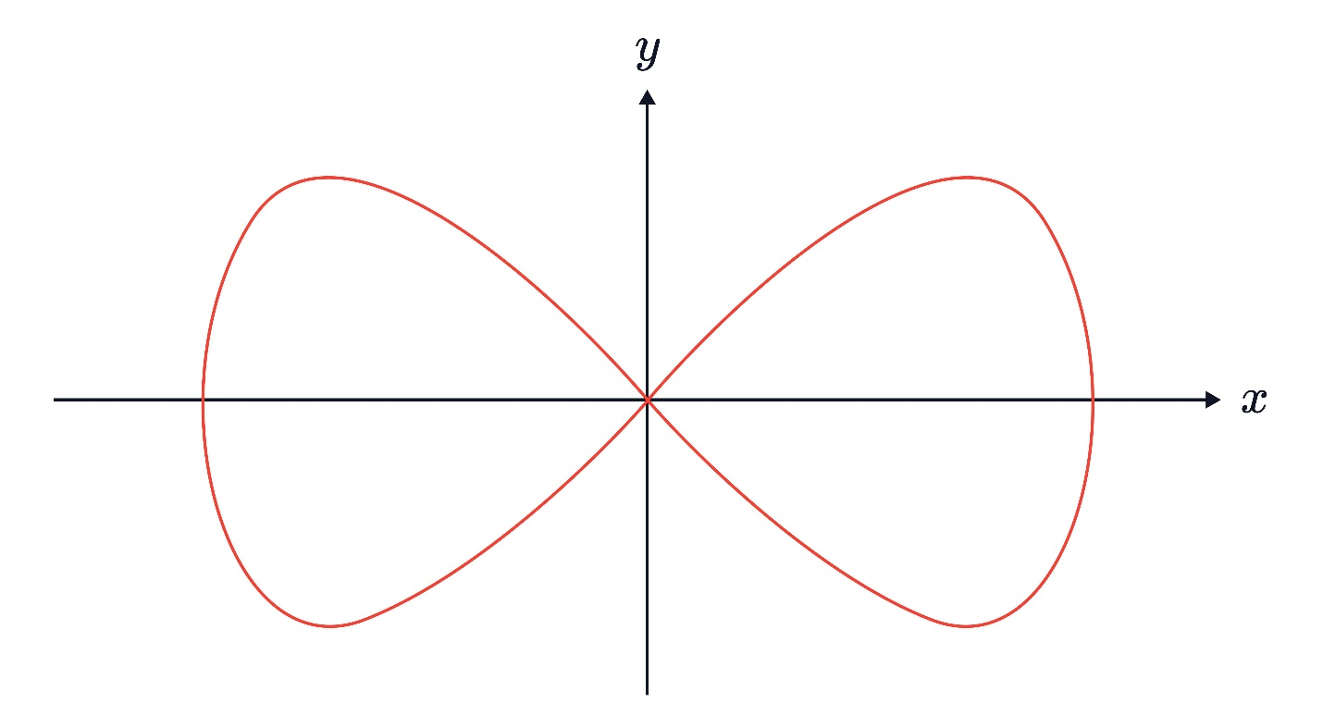

Key Points
# Source: AI Source: Provided by: [Data Path: Persons Table -> ID Column: 1, Name_En Column: Motasem Essam] -> From: [ChatGPT] on [7/25/2026]
A curve is:
$$\boxed{\text{A continuous bending path in a two-dimensional plane}}$$
The most important classification properties are:
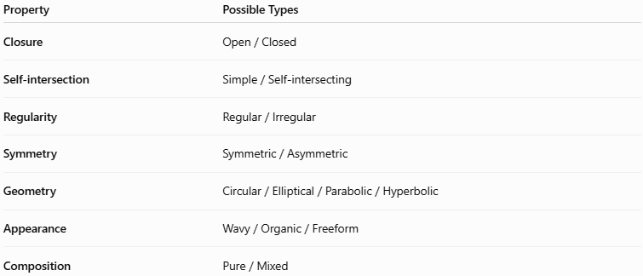
Property | Possible Types
Closure | Open / Closed
Self-intersection | Simple / Self-intersecting
Regularity | Regular / Irregular
Symmetry | Symmetric / Asymmetric
Geometry | Circular / Elliptical / Parabolic / Hyperbolic
Appearance | Wavy / Organic / Freeform
Composition | Pure / Mixed

Conclusion
# Source: AI Source: Provided by: [Data Path: Persons Table -> ID Column: 1, Name_En Column: Motasem Essam] -> From: [ChatGPT] on [7/25/2026]
Curves are fundamental objects in Plane Geometry representing continuous bending paths in a two-dimensional plane. They can be classified by their closure, self-intersection, regularity, symmetry, mathematical form, and composition.
The most fundamental division is:
$$\boxed{\text{Curves}→\text{Open Curves} | \text{Closed Curves}}$$
From there, curves can be further classified as circular, elliptical, parabolic, hyperbolic, wavy, spiral-like, organic, freeform, irregular, or mixed depending on their geometric properties and construction.

